SMARTPUBLIC RESTROOM USING IOT

IBM NAAN MUDHALVAN

**Phase 3 submission**

COURSE NAME: INTERNET OF THINGS

GROUP:07

PROJECT NUMBER : 08

TITLE:SMART PUBLIC RESTROOMS

YEAR : lll

DEPARTMENT : ELECTRONICS AND COMMUNICATIONS ENGINEERING

PROJECT SUBMITTED TO : IBM (SkillUp Online)

TEAM MEMBER

OBJECTIVE:

This article told that we will start to building our project by deploying IoT devices and then developing a Python script on the IoT devices as per the project requirement

INTRODUCTION:

Smart public restrooms are becoming increasingly popular, as they offer a number of advantages over traditional restrooms. Smart restrooms use the Internet of Things (IoT) to collect data on usage, occupancy, and environmental conditions.

* Improved efficiency: It help us to improve the efficiency of public restrooms by automating tasks such as cleaning and maintenance
* Improved cleanliness: Smart restrooms can help to improve the cleanliness of public restrooms by tracking usage and occupancy patterns. This information can then be used to ensure that the restrooms are cleaned more frequently during peak times.
* Improved user experience: Smart restrooms can provide users with information and amenities such as real-time occupancy data, wayfinding, and feedback surveys. This can help to improve the overall user experience and make public restrooms more accessible and inclusive.

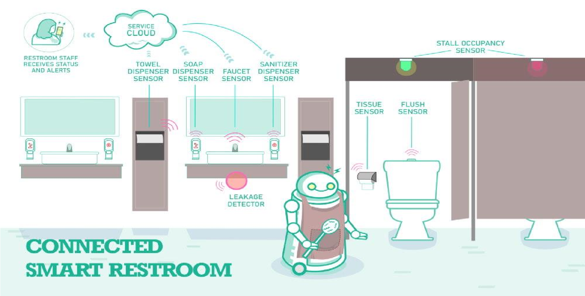

CIRCUIT DIAGRAM:

*Figure*

*1*

*:*

*SMART PUBLIC RESTROOM MONITORING AND MAINTAINING BY USING IOT*

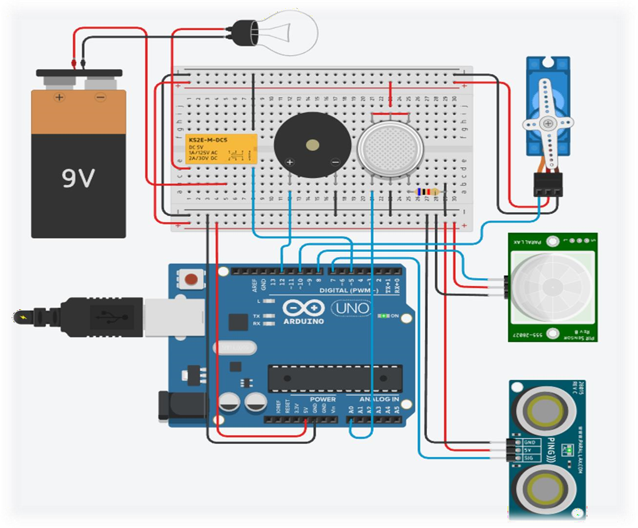

HARDWARE COMPONENTS DESCRIPTION:

1.ULTRASONIC SENSOR:

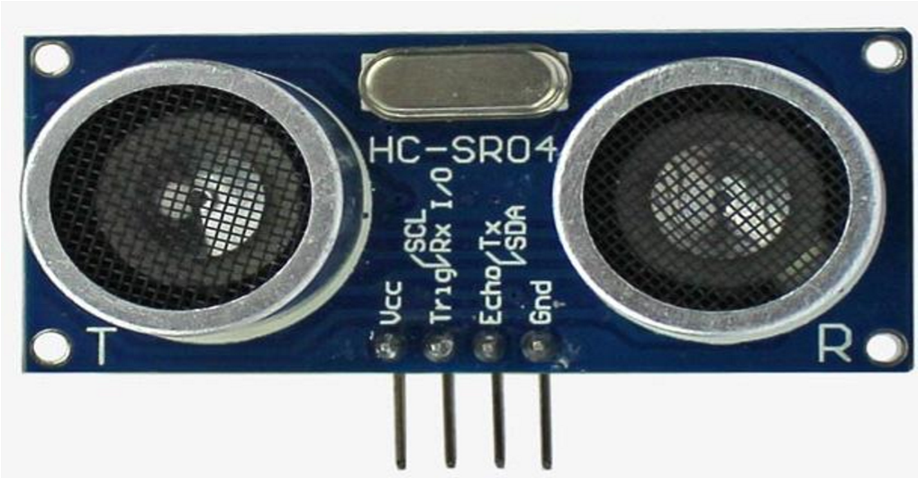

* Ultrasonic sensors are electronic devices that calculate the target’s distance by emission of ultrasonic sound waves and convert those waves into electrical signals.
* The speed of emitted ultrasonic waves traveling speed is faster than the audible sound.
* There are mainly two essential elements which are the transmitter and receiver. Using the piezoelectric crystals, the transmitter generates sound, and from there it travels to the target and gets back to the receiver component
* .To know the distance between the target and the sensor, the sensor calculates the amount of time required for sound emission to travel from transmitter to receiver.

2.MICRO SERVO MOTOR:

* A servo motor is a type of electric motor that can rotate or move to a specific position, speed, or torque based on an input signal from a controller.A servo motor consists of three main components: motor ,sensor ,controller
* A **setpoint signal**: This is an analog or digital signal that represents the desired position, speed, or torque of the output shaft.
* A **feedback signal**: This is an analog or digital signal that represents the actual position, speed, or torque of the output shaft measured by the sensor.
* The controller compares these two signals and calculates an error signal that represents the difference between them.

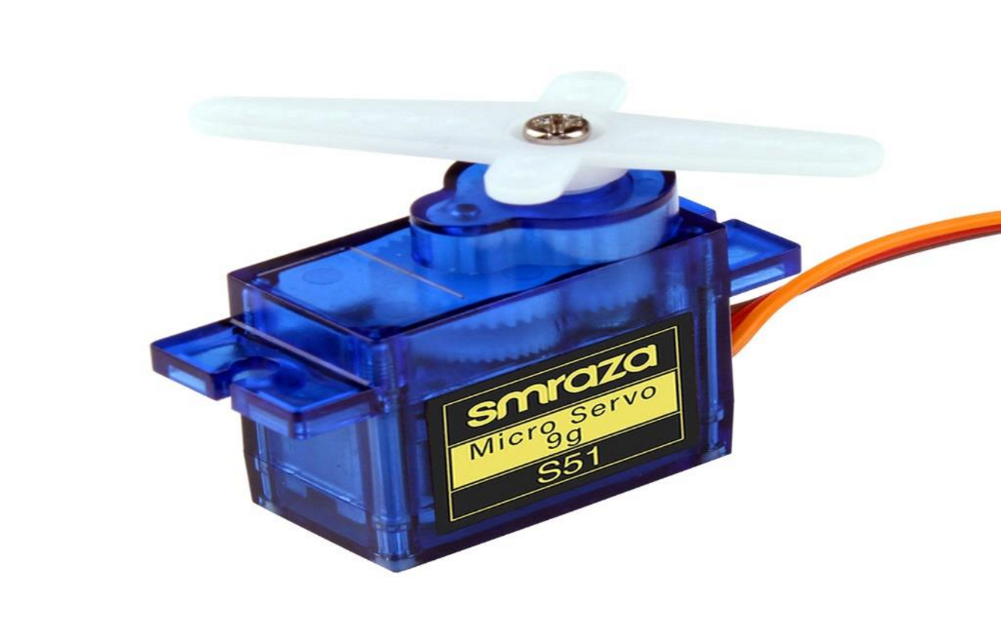

3.BUZZER:

* A buzzer is an electronic device that **produces a sound** when powered by a direct current (DC) voltage, it is commonly used in alarms, timers, computers, and other devices that need to make a sound signal.
* In IoT (Internet of Things), a buzzer can be used as an output device to indicate the status of a sensor, a device, or a system.

For example, a buzzer can be used to alert the user when the temperature is too high or low, when the motion is detected.

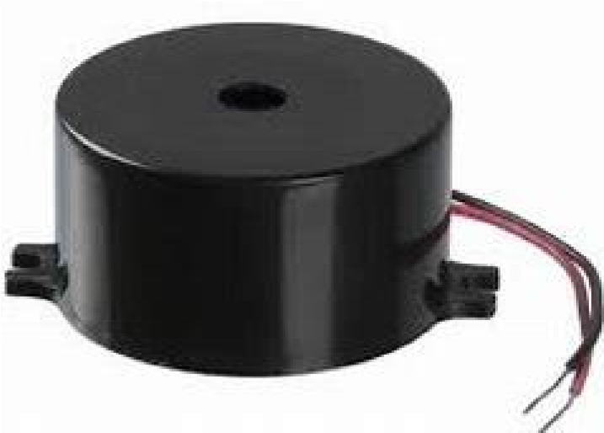

4.PIR SENSOR

* A PIR is a **Passive Infra Red sensor**. PIR is an electronic sensor which detects the changes in the infrared light across certain distance and gives out an electrical signal at its output in response to a detected IR signal.
* It can detect any infrared emitting object such as human beings or animals if it is the range of the sensor, or moves away from the range, or moves within the range of the sensor.
* In the front of the sensor it has a small window like structure which is mounted with silicon. This silicon film protects the sensing elements.

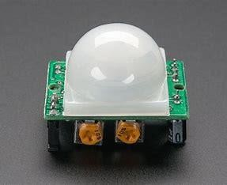

5.ARDUINO UNO:

* Arduino Uno is a popular open-source microcontroller board that can be used for various projects involving electronics, robotics, sensors, etc It is a microcontroller board based on the ATmega328P ([datasheet)](http://ww1.microchip.com/downloads/en/DeviceDoc/Atmel-7810-Automotive-Microcontrollers-ATmega328P_Datasheet.pdf).
* It has 14 digital input/output pins (of which 6 can be used as PWM outputs), 6 analog inputs, a 16 MHz ceramic resonator (CSTCE16M0V53R0), a USB connection, a power jack, an ICSP header and a reset button.
* It contains everything needed to support the microcontroller.
* Simply connect it to a computer with a USB cable or power it with a ACto-DC adapter or battery.
* You can program the Arduino Uno using the Arduino Software (IDE), which is an integrated development environment that supports both online and offline platforms.

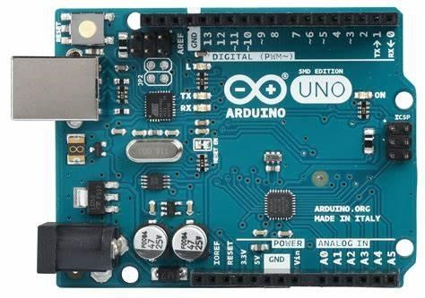

6.BATTERY

9-volt batteries are electric batteries that supply a nominal voltage of 9 volts and are used in various devices like cameras, toys, smoke detectors, and more. They have different sizes, capacities, and chemistries, and a common size is PP3. Some 9-volt batteries have a tough outer metallic casing, different terminal shapes, and no mercury inside, such as the Energizer 9V alkaline

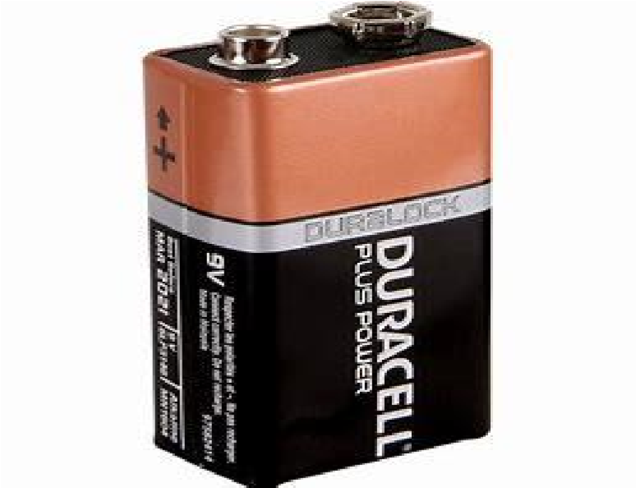

SOURCE CODE

#include <Servo.h> int ULT = 7; int PIR = 8; int BUZZ = 12; int GAS = A0; int BULB = 5; int JARAKU = 0; int KADARG = 0; int JARAKP = 0; int pin = 10;Servo SERV; long bacaULT(int pin) //fungsi penghitungan durasi pantulan

{

pinMode(pin, OUTPUT);

digitalWrite(pin, LOW); delayMicroseconds(2); digitalWrite(pin, HIGH); delayMicroseconds(10); digitalWrite(pin, LOW); pinMode(pin, INPUT); return pulseIn(pin, HIGH);

}

void setup()

{

pinMode(ULT,INPUT); pinMode(PIR,INPUT); pinMode(GAS,INPUT); pinMode(BUZZ,OUTPUT); pinMode(BULB,OUTPUT);

SERV.attach(pin);

Serial.begin(9600);//inisialisasi komunikasi serial 9600 bps

}

void loop()

{

JARAKU = 0.01723*bacaULT(ULT);//membaca jarak objek

KADARG = analogRead(GAS);//membaca kadar gas

JARAKP = digitalRead(PIR);//membaca pergerakan objek

//Program Sensor Ultrasonik if (JARAKU<=120)

{

digitalWrite(BULB,HIGH); Serial.print("\nULT : Objek Dideteksi! ");

Serial.print(JARAKU,DEC);

Serial.print(" (Lampu Nyala)");

}

else

{

digitalWrite(BULB,LOW);

Serial.print("\nJarak: ");

Serial.print(JARAKU,DEC);

Serial.print(" (Lampu Mati)");

}

//Program Sensor Gas if (KADARG>=400)

{

tone(BUZZ,500);

Serial.print("\nGAS : Gas Dideteksi! ");

Serial.print(KADARG,DEC);

Serial.print(" (Buzzer Bunyi)");

}

else

{

noTone(BUZZ);

Serial.print("\nKadar: ");

Serial.print(KADARG,DEC);

Serial.print(" (Buzzer Berhenti)");

}

//Program Sensor PIR if (JARAKP==HIGH)

{

Serial.print("\nPIR : Objek Bergerak Dideteksi!");

Serial.print(" (Motor Nyala)\n"); SERV.write(180); delay(1000);

}

else

{

Serial.print("\n(Motor Mati)\n"); SERV.write(0); delay(300);

}

}

CONCLUSION:

Smart restrooms are still a relatively new technology, but they have the potential to revolutionize the way we use public restrooms. As the technology continues to develop, we can expect to see even more smart restrooms being installed in public places.

********